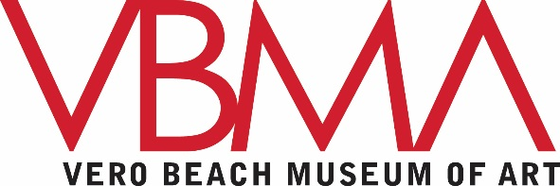
PUBLIC PROGRAMS MANAGER

Working under the general supervision of the Director of Education, the Public Programs Manager makes the VBMA’s collection and special exhibitions accessible to visitors of all ages —including adults, children, and families—through a broad range of creative programming.

Responsibilities:

- Conceptualizes, develops, and executes exhibition- and collection-related public programs, including lectures, film series, concerts, performances, community events, family activities and studio projects, and new initiatives.
- Works collaboratively to plan and implement major exhibition opening lectures and lecture series;
- Contacts presenters, performers, etc., about programs; produces correspondence, contracts, and travel itineraries; maintains program files; and produces check requests.
- Coordinates public program staffing needs, including recruiting, scheduling, and overseeing volunteers and staff assisting with programs.
- Works with appropriate departments and individual staff members to coordinate all public program set-up needs.
- Evaluates public programs to make sure initiatives are meeting audience needs.
- Supervises Film Studies Coordinator, teaching artists, interns, volunteers (including docents), and teen volunteers; in coordination with the Director of Education, recruits, interviews, and recommends candidates for hire, as necessary.
- Oversees the development and management of the VBMA’s interactive children’s space, the Art Zone.
- Prepares and manages appropriate public program budgets; monitors expenses accordingly.
- As requested by Director of Development, participates in the grant-writing and reporting processes.
- Promotes the VBMA’s public programs by participating in local, state, and national professional development; stays abreast of lifelong learning research and best practices for public programs.
- Works with Communications and Marketing staff on promotional materials and press releases.

Education and Professional Qualifications:
- Bachelor’s degree in art history, art education, education, museum education, or related field; MA preferred
- At least 2-3 years of museum experience focused on successful programming for a variety of audiences

Requirements:

- Creative thinker
- Highly organized and detail oriented
- Knowledge of a broad range of periods and styles in art as well as visual literacy strategies and teaching methods
- Proven track record of creating mission-driven programming that aligns audience needs with collections and exhibitions
- Experience cultivating high-profile speakers and managing high-volume programs
- Superior written and verbal communication skills, including excellent public speaking abilities
- Proven ability to manage multiple programs for multiple audiences concurrently
- Experience supervising staff and/or volunteers.

The Vero Beach Museum of Art is an Equal Opportunity Employer, and does not discriminate on the basis of sex, race, religion, age, handicap or national origin.

If you or anyone you know is interested in this position, please contact Bonnie Wetherell at bwetherell@verobeachmuseum.org

